**Technical Documentation – PENC MiddleWare – Liferay Service Control**

1. Workflow – Stops, Starts, Restarts Liferay Services. This workflow only works on a single node at a time (i.e. it will not stop/start/restart both tliferay71bcp and tliferay72bcp at the same time). If the idea is to process on both nodes of a liferay environment it will have to be submitted twice.

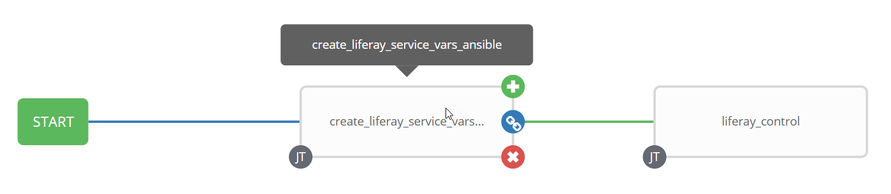

1. Survey – User Supplied Variables

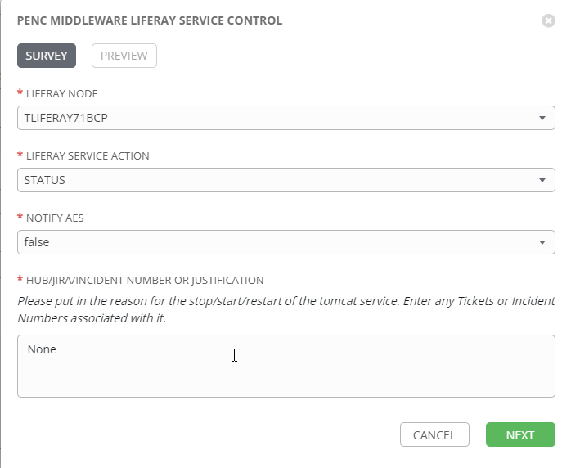

| **Survey Extra Variables** | **Prompt** | **Type** | **Description and Usage** |
| --- | --- | --- | --- |
| liferay_env | Liferay Node | Multiple Choice Single Pick | Drop down list of the liferay node for the command to be executed on.  Current List:  DLIFERAY71BCP  DLIFERAY72BCP  TLIFERAY71BCP  TLIFERAY72BCP  MLIFERAY71BCP  MLIFERAY72BCP  PLIFERAY71BCP  PLIFERAY72BCP |
| liferay_command | Liferay Service Action | Multiple Choice Single Pick | The action to execute  RESTART  START  STATUS  STOP |
| notify_aes | Notify AES | Multiple Choice Single Pick | If set to true send an email to the email addresses defined in {{aes_mail_list}}. |
| aes_note | HUB/JIRA/INCIDENT Number or Justification | Textarea (20,000 characters) | Any information entered here will be included in the emails generated. |

1. Jobs Used by the workflow - http://owl.penc.local:18080/svn/deploy_automation/trunk/Ansible_PlayBooks/Utilities

| **Job Template** | **Ansible Playbook** | **Credentials / host** | **Project** | **Description and Usage** |
| --- | --- | --- | --- | --- |
| create_liferay_service_vars_ansible | create_liferay_service_vars_ansible.yml | None – runs on localhost as awx linux user | Utilities | Creates Variables/Artifacts for use within the workflows, based on the User supplied survey results.  Artifacts Defined with examples  date_time: '20201218_1633'  liferay_env: DEV  liferay_host: dliferay71bcp  liferay_port: 4443  liferay_protocol: https  liferay_proxy: myaccountdev1.pensionsbc.ca |
| liferay_control | liferay_control.yml | pencmw for {{liferay_host}} | Utilities | On {{liferay_host}}:  With {{liferay_command}} == ‘STOP’ or ‘RESTART’  retrieves the process id for the Liferay tomcat service to be stopped into {{liferay_tomcat_pid}} variable.  executes ‘/pencmw_common/MOS/scripts/ansible_liferay7_stop.sh  waits for the /proc/{{liferay_tomcat_pid.stdout}}/status to longer exist (i.e. Liferay tomcat process no longer exists)  With {{liferay_command}} == ‘START’ or ‘RESTART’  Archive the catalina.out file  Execute ‘/pencmw_common/MOS/scripts/ansible_liferay7_start.sh’  Wait for the Lifray Tomcat to complete startup by looking for 'org.apache.catalina.startup.Catalina.start Server startup' in the catalina.out file.  With {{liferay_command}} == ‘STATUS’ or ‘STOP’ or ‘START’ or ‘RESTART’  Checks the url {{liferay_protocol}}://{{liferay_host}}.penc.local:{{liferay_port}}  Checks the url {{liferay_protocol}}://{{liferay_proxy}}  Sends an email to the Ansible Tower user who initiated the workflow with the results  If {{notify_aes}} is set to true send an email to the addresses defined in {{aes_mail_list}} with the results  With {{liferay_command}} == ‘STATUS’ or ‘START’ or ‘RESTART’  Checks page returned from url {{liferay_protocol}}://{{liferay_host}}.penc.local:{{liferay_port}} for the Liferay Sitebacker string – if it is not there FAIL the workflow. |

1. Workflow Extra Vars – Defined at the Workflow Level

|  |  |  |
| --- | --- | --- |
| **Extra Variable** | **Example Values** | **Description and Usage** |
| aes_mail_list | ---  aes_mail_list:  [Mike.Charchuk@dxcas.com](mailto:Mike.Charchuk@dxcas.com) | If this variable is defined to anything other than ‘’ and {{notifiy_aes}} == true, and email will be sent addresses defined in aes_mail_list on the actions executed.  Note: the following are valid aes_mail_list entries:  aes_mail_list: ‘’  aes_mail_list:  [Mike.Charchuk@pensionsbc.ca](mailto:Mike.Charchuk@pensionsbc.ca)  [Mike.Charchuk@dxcas.com](mailto:Mike.Charchuk@dxcas.com)  aes_mail_list:  [Mike.Charchuk@pensionsbc.ca](mailto:Mike.Charchuk@pensionsbc.ca) |